https://apnews.com/article/noam-chomsky-jeffrey-epstein-files-valeria-chomsky-fb288dc6cf733fd3dbfdec86fec8b14a?utm_source=firefox-newtab-en-us
U.S. News
Valeria Chomsky admits ‘serious errors in judgment’ over Jeffrey Epstein ties
By HILLEL ITALIE
Updated 3:35 PM EST, February 11, 2026
NEW YORK (AP) — The wife of Noam Chomsky is acknowledging “serious errors in judgment” in the wake of new revelations about the couple’s ties to the disgraced financier Jeffrey Epstein. Valeria Chomsky also says she and her husband never witnessed any inappropriate behavior.
“Noam and I recognize the gravity of Jeffrey Epstein’s crimes and the profound suffering of his victims,” Valeria Chomsky wrote in a statement she shared this week with The Associated Press. “Nothing in this statement is intended to minimize that suffering, and we express our unrestricted solidarity with the victims.”
The friendship between Epstein and Noam Chomsky, the influential activist and pioneering linguist, has been known for several years. But the latest release of documents by the Justice Department show a more extensive relationship than previously reported on and includes a memo suggesting that Chomsky was advising Epstein on how to rehabilitate his public image.
Admirers of Chomsky, a longtime critic of the U.S. political and media establishment, have expressed revulsion. Vijay Prashad, who has written books on Cuba and the Middle East with Chomsky, released a letter last week saying he was “disgusted by Epstein’s pedophilia, and so by Noam’s friendship with him.”
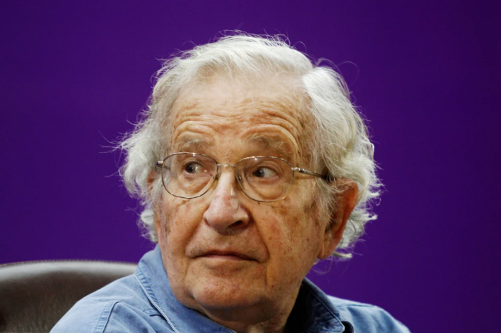
In her public statement, Valeria Chomsky notes that she was speaking for herself and for her husband, who is 97 and “confronting significant health challenges” since he suffered a stroke in 2023. She writes that they were naive and uninformed, and cites Noam Chomsky’s “overly trusting nature” as a reason for their “serious errors in judgment.”
According to Valeria Chomsky, the two first met Epstein in 2015, and were unaware at the time of his 2008 jail term for soliciting prostitution from an underage girl. By 2015, the accusations against Epstein had been the subject of hundreds of news articles, many of which detailed allegations that he had paid dozens of underage girls for sex.
“When we were introduced to Epstein, he presented himself as a philanthropist supporting science and a financial expert,” she wrote. “By presenting himself this way, Epstein gained Noam’s attention, and they began corresponding. Unknowingly, we opened a door to a Trojan horse.”
Valeria Chomsky goes on to recall that “Epstein began to encircle Noam, sending gifts and creating opportunities for interesting discussions in areas Noam has been working on extensively. We regret that we did not perceive this as a strategy to ensnare us and to try to undermine the causes Noam stands for.”
She writes that they visited Epstein once at his ranch in New Mexico, attended dinners at his Manhattan townhouse and stayed at his apartment a few times. The relationship was friendly, but entirely professional, with no “children or underage individuals present.”
In emails exchanged in 2019, months before Epstein was arrested on sex trafficking charges and killed himself in his jail cell, Epstein laments his “putrid” reputation. In response, Chomsky comments on the “horrible way” Epstein has been treated by the media and advises him to ignore it. Valeria Chomsky says her husband’s remarks should be “read in context.”
“Epstein had claimed to Noam that he (Epstein) was being unfairly persecuted, and Noam spoke from his own experience in political controversies with the media,” her statement reads in part. “Epstein created a manipulative narrative about his case, which Noam, in good faith, believed in. It is now clear that it was all orchestrated, with at least one of Epstein’s intentions being to have someone like Noam help repair his reputation by association.”

